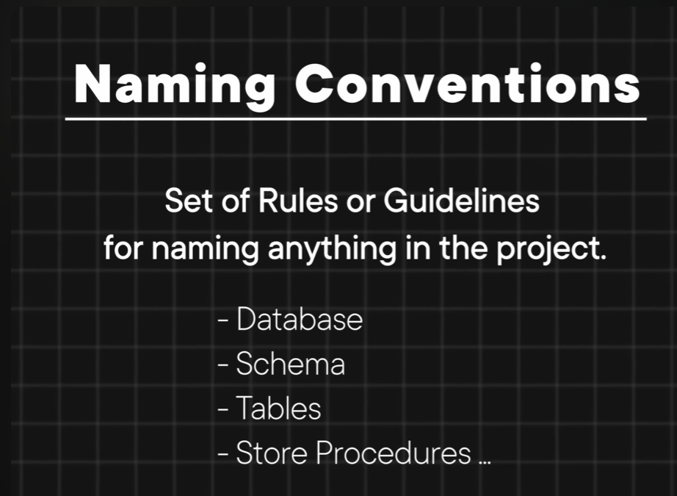

Details are in link below :-
\\Reference\docs\naming_conventions.md

